JSON Practice
Program Results:
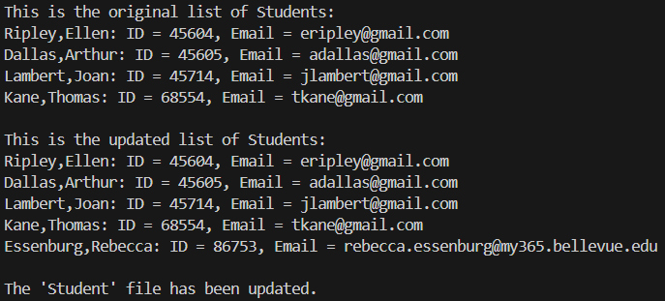

File Change Notification:
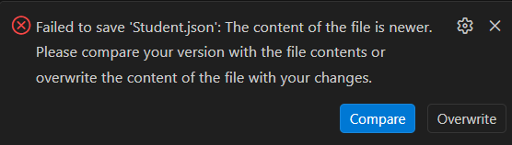
This is the only pop-up I was able to find that occurs in VSCode. It happens only if I am trying to save changes made in VSCode that do not match what is in the save file when the save file contents are newer. When the code changes the JSON file, it automatically reloads the JSON file in both VSCode and Notepad- neither give me the popup option to reload.

JSON File New Contents:
[
{
"F_Name": "Ellen",
"L_Name": "Ripley",
"Student_ID": 45604,
"Email": "eripley@gmail.com"
},
{
"F_Name": "Arthur",
"L_Name": "Dallas",
"Student_ID": 45605,
"Email": "adallas@gmail.com"
},
{
"F_Name": "Joan",
"L_Name": "Lambert",
"Student_ID": 45714,
"Email": "jlambert@gmail.com"
},
{
"F_Name": "Thomas",
"L_Name": "Kane",
"Student_ID": 68554,
"Email": "tkane@gmail.com"
},
{
"F_Name": "Rebecca",
"L_Name": "Essenburg",
"Student_ID": 86753,
"Email": "rebecca.essenburg@my365.bellevue.edu"
}
]

